Front end

The most critical and error prone parts of the csulbsharklab website are user authentication and individual email setup. We will go through a few scenarios and perform test cases for each part.

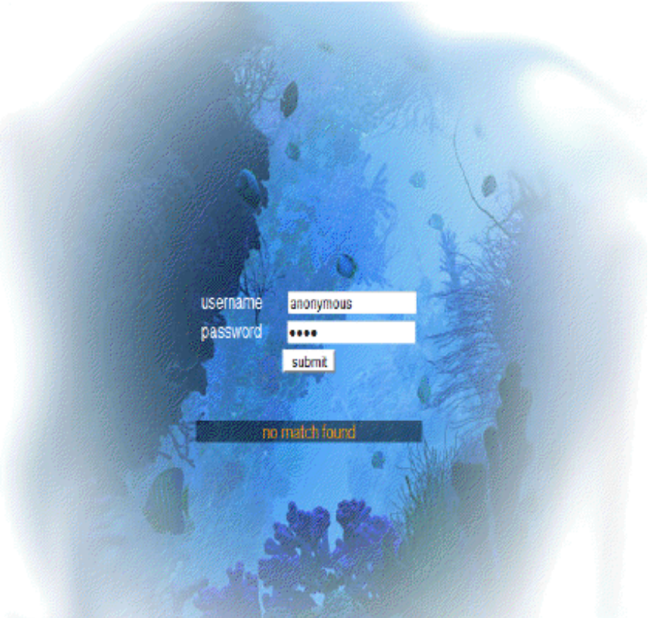
Logging into www.csulbsharklab.com

1)Lets test the error notification for an invalid user.

- Start by entering the url www.csulbsharklab.com into the address bar in your web browser.

- Try entering an invalid username and password:
- username: anonymous
- password: 1234
- Click the submit button when finished.
An error notification should appear under the submit button saying “no match found.”
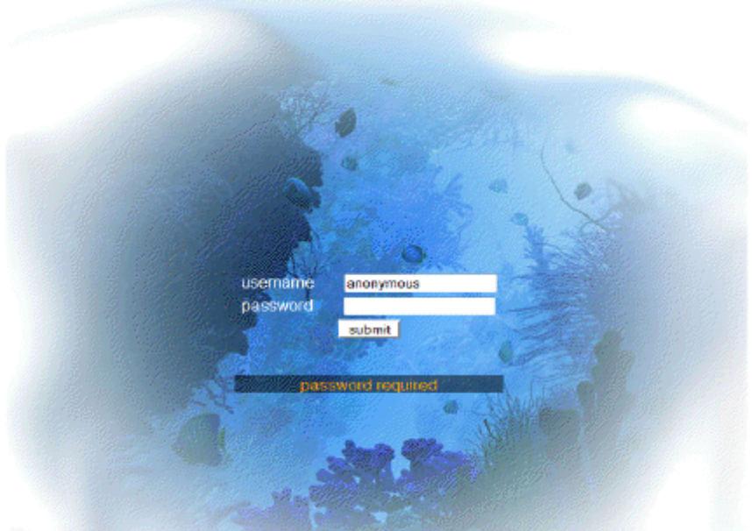
2) Lets test the error notification for a user that doesn’t enter a password.
- Try entering a username and leaving the password empty:
-username: anonymous
-password:
- Click the submit button when finished.
An error notification should appear under the submit button saying “password required”

Changing email address and preference

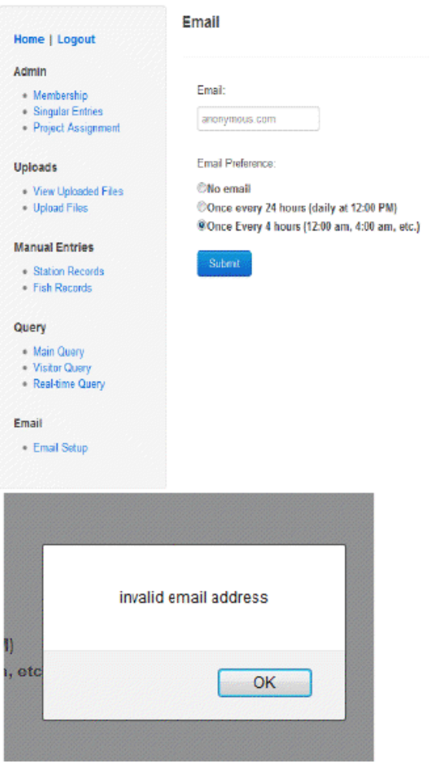
Note: To begin this test case scenario, the tester must already be logged into the website.
1)Lets test the error notification for an invalid email address.
- Navigate to the email setup webpage by click on the Email Setup hyperlink in the main menu located on the left of your current page.
- If your account already has an email address set, it should appear in the textbox under the Email: label. If not it will appear blank. In either case, try entering an invalid email address and an email preference:
- Email: anonymous.com
- Email Preference: Once Every 4 Hours
- Click the Submit button when finished.

A dialog should appear with an error notification saying “invalid email address.”

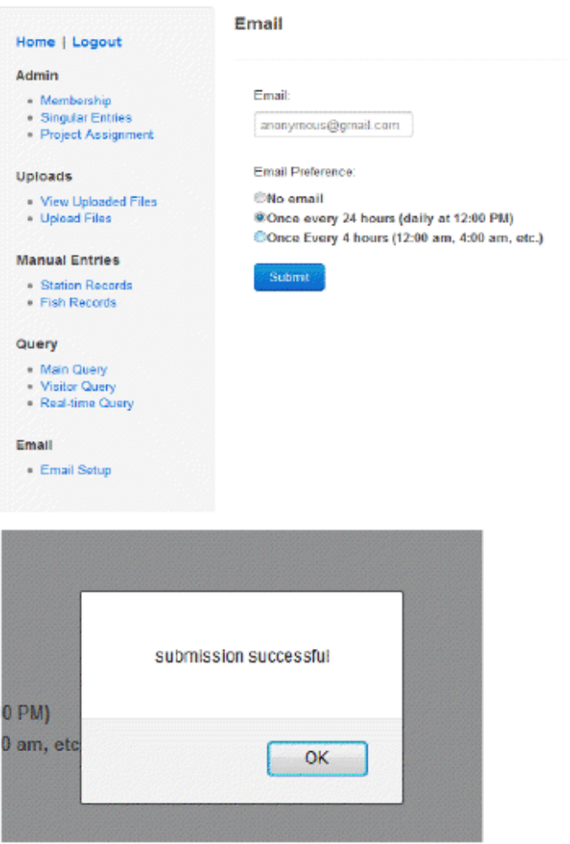
- Lets test the scenario when a valid email address is entered.

- Enter a valid email address
- Email: anonymous@gmail.com
- Email Preference: Once Every 24 Hours
- Click the Submit button when finished.

A dialog should appear saying “submission successful.” Once the user clicks ok, they should be redirected to the home page.

Back end
From the end-user's perspective, the back-end is very simple, and only has a couple operation.

Turning On/Off a Receiver
- The user toggles a receiver on/off using the button labeled at such.
- a. When turned off, the status indicator in the UI should turn red, and the receiver should then be in storage mode and not send anything to the system.
b. When turned on, the status indicator should turn green, and the receiver should begin recording in real-time mode and transmit detections to the database.

Configuring a New Receiver (Relatively Error-prone)
- The user connects a new receiver via serial port (virtual or not).
- The UI should find the new receiver and display it in the list of receivers. It will then attempt to turn the receiver on and put it in real-time mode. If successful, the status indicator for that receiver will turn green.

Recommendation for Test Program
- The only input the system will receive will come from the receiver over the serial port.
- For testing purposes, messages can be directly enqueued into the Dispatcher to mimic messages coming in over the serial port, using the Dispatcher.enqueue(RealTimeEvent) procedure.
- Inserted input can be output that was directly sent from the receiver during test runs of it using the VR2C tool, as well as testing garbage.
- Because the Dispatcher sends the commands to each module in the system, it ensures that all aspects of the system are tested so long as a wide variety of messages are used.
- Special attention should be given to messages that trigger an attempted insertion into the database.

